Type 1 Diabetes Education Pathway- Recommendations
Scottish Diabetes Education Advisory Group

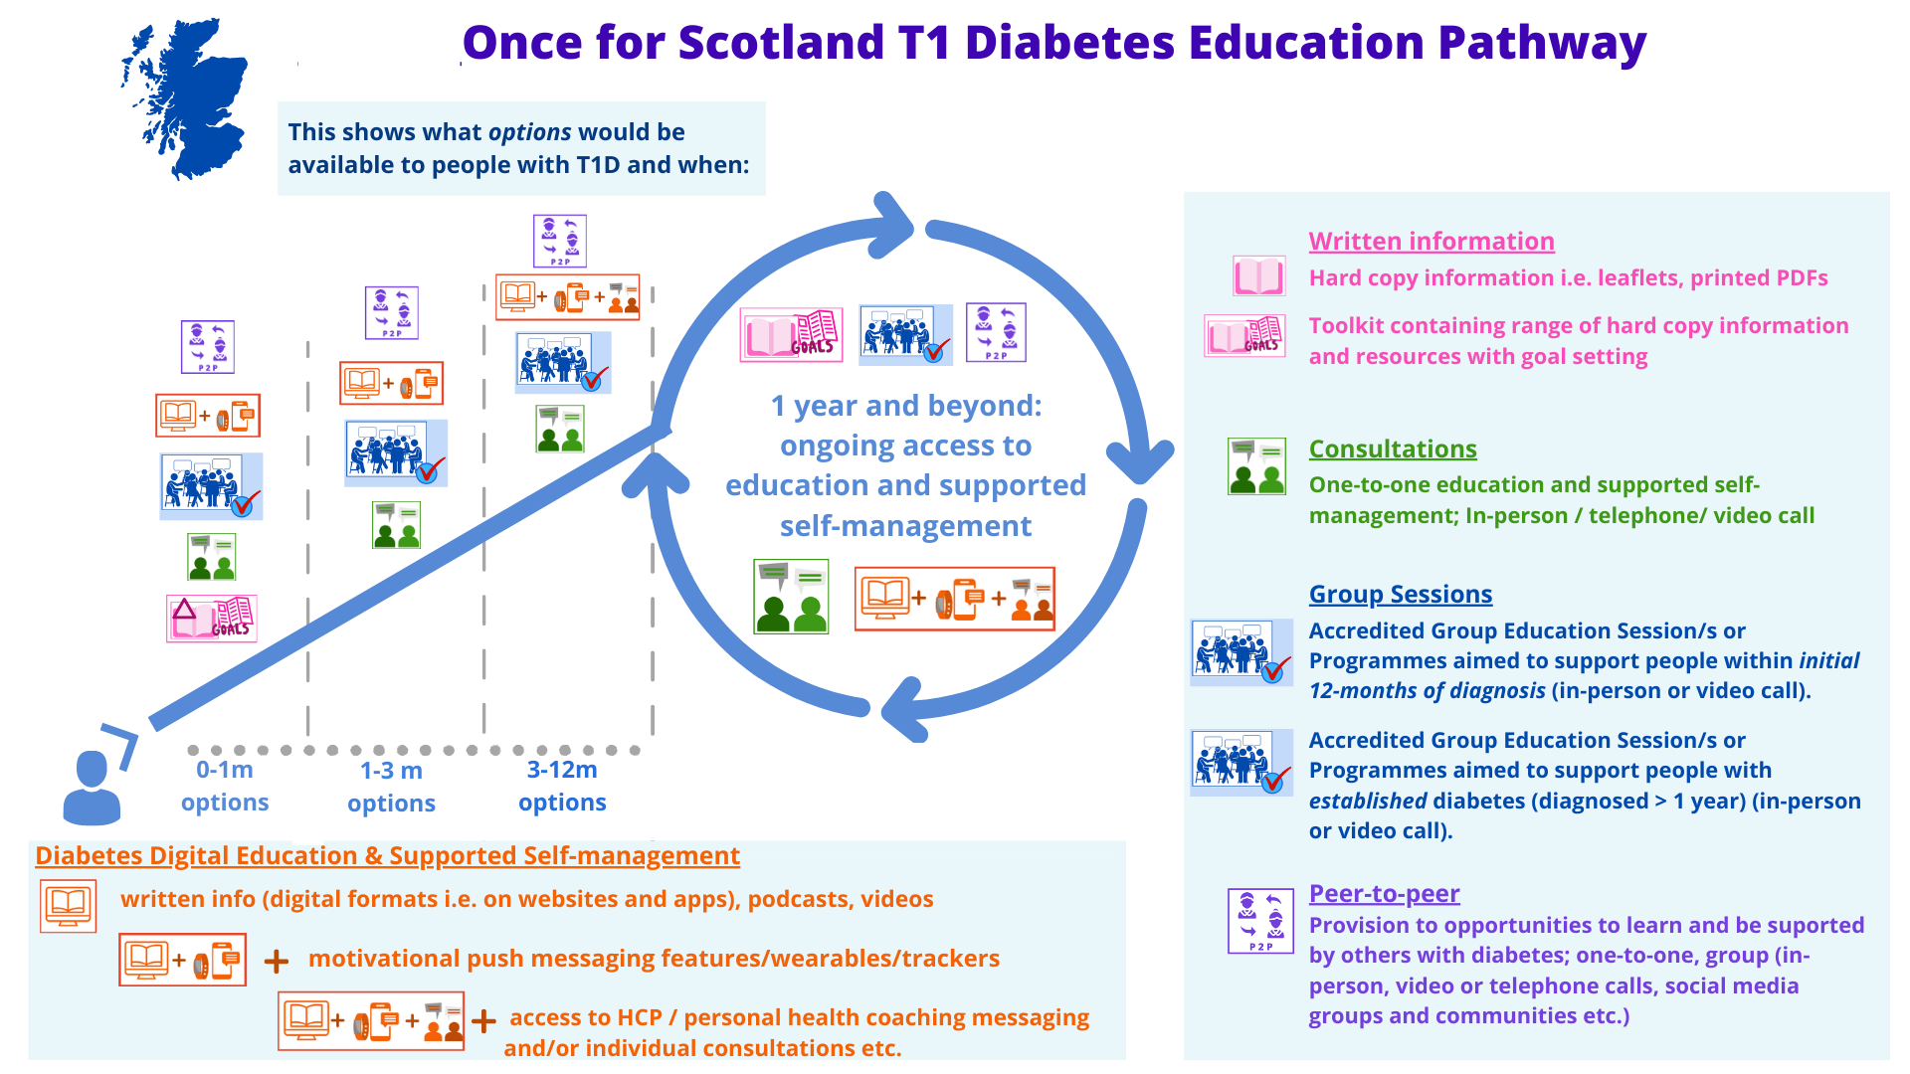

Vision

Our vision is that all health boards in Scotland provide a range of self-management tools and services to enable everyone living with diabetes to better manage their condition and live well.

Purpose of this Document

This document is intended to provide an outline of the standards for the provision of education at the various stages throughout an individual’s diabetes journey.

It is intended to guide, rather than replace local processes, to support local teams to integrate the various stages of the pathway to suit their population needs.

Who is this document intended for?

This document is intended to be used by diabetes service managers and diabetes MCNs to ensure that consistent patient pathways are implemented across Scotland.

A separate, accessible version of this document will be made available to give people living with diabetes an overview of the care and choices they should expect to receive.

Background

In April 2022, the Scottish Diabetes Education Group hosted a virtual event for health care professionals with an interest in diabetes education to discuss the potential for a ‘Once for Scotland’ pathway for diabetes self-management support and education. Over 200 delegates attended, with representation from every NHS Board in Scotland.

The feedback from the day was overwhelmingly positive, with over 95% agreeing that there is value in creating a Once for Scotland pathway for both Type 1 and Type 2 education.

Short Life Working Groups were established for Type 1 and Type 2 Diabetes with volunteers representing all 14 NHS Boards on each group. The groups have worked through each stage of the pathway in an iterative way, sharing the resources that are currently being used in each area and what works for people with diabetes. See Annexe A for recommendations.

We commissioned the Health and Social Care Alliance to undertake lived experience engagement and produce a report outlining the experiences of people living with diabetes in accessing education and self-management support in order to help shape the focus of the groups. Highlights from the report include the expressed desire for emotional wellbeing and mental health support, the importance of a flexible approach to individual needs, along with a preference for face to face support or a mix of face to face with digital options.

Following the initial pathway development, the Alliance then held several further focus group sessions to allow people living with diabetes the opportunity to review the pathway.

Toolkit

Our aim is for all resources and links to be hosted as a national digital toolkit, enabling healthcare professionals from across the country to access them from a central location. We are working towards an NHS Inform hosted page which would be accessible to both the public and professionals, however for now all of the resources can be found on the files section of our MS Teams Channel.

Boards are also able to upload their resources to the Right Decisions Platform for healthcare professional and/or public use, and these local toolkits can be accessed by all as we work towards a national toolkit.

It is essential that any educational resources listed are of a high standard, easy to access and, have the appropriate accreditation in relation to structured education and self-management. While we aim for a more centralised digital toolkit, we will ensure people living with diabetes are made aware of the range of options available to them.

Specific Workstreams

We will continue to work with the Scottish Diabetes Group subgroups and in conjunction with specific areas such as optometry, pregnancy and Foot Action Group to bring together the specific education requirements for the processes of care and specialty areas.

Equalities Considerations

One of the main drivers for this work is the impact of inequalities on people’s ability to manage their diabetes. In order to improve services, we must improve accessibility, availability and empowerment.

We want everyone living with diabetes to be enabled to manage their condition; so we need to adapt certain stages of the pathway to ensure they are accessible to all.

For example, resources should be available in a range of formats such as alternative languages and easy-read versions. We also know there is a need to ensure that people with poor literacy are not discouraged from taking up educational opportunities.

Whilst we have promoted digital resources as part of the pathway, our approach is ‘digital first’ rather than ‘digital only’ and we would still expect face to face support to be available to those who need/prefer it. We would encourage all boards to address individual needs and offer those with more complex needs a programme most suitable to them.

The use of regional approaches to the use of digital resources was discussed by the group as a useful way of removing geographic barriers to accessing diabetes education for those living in remote and rural areas.

We have completed a full EQIA on this project and the key points for local consideration can be found in Annex B.

HCP education in support of pathway delivery

To deliver high quality support and education for people with diabetes we require a highly skilled and supported workforce. Diabetes education should be embedded at all stages of staff training for both specialist and generalist clinicians; undergraduate and postgraduate.

We recognise the wide range of professionals who deliver diabetes education and want to ensure that they are enabled to support people with diabetes to self-manage their condition. Healthcare professionals should be supported to use the delivery of the processes of care for diabetes as opportunities to embed education and self-management.

The next stage in the development of this work would be to work with NHS Education Scotland (NES) to standardise and promote the use of medical education principles and develop links with TURAS, as well as discussing with our undergraduate education partners how we can better embed diabetes education within healthcare students’ training.

Local Implementation of the Recommendations

We will promote the recording of education uptake through SCI Diabetes to ensure we can accurately measure the progress of the pathway’s implementation and allow Boards to benchmark their success. We aim to review and incorporate patient related outcome measurements.

We propose using the established MS Teams channel and SLWG membership to form a peer-network of clinicians from across Scotland who will be able to support implementation of the pathway across Board areas through sharing good practice whilst remaining solution-focused to deal with challenges.

Moving forward, we would expect all Boards to be delivering the recommended range of educational resources to everyone living with diabetes, as highlighted in the pathway. All healthcare professionals who regularly interact with those living with diabetes should be aware of and be able to highlight these resources to them.

Future Plans

We will collaborate with partners at the Centre for Sustainable Delivery to incorporate and embed educational opportunities as core to the innovation pathways. We will continue to work closely with team delivering the current Closed Loop Systems project, as well as future initiatives to support our ‘Once for Scotland’ approach. We continue to work alongside people living with diabetes and our third sector colleagues at Diabetes Scotland and JDRF to support lived experience to be embedded in the pathway.

Whilst there are specific educational resources for Type 1 Diabetes, we should also consider adopting self-management programmes and education that works across disciplines e.g. cardiovascular risk prevention to identify common values and needs for our citizens in partnership with our third sector, social & health care professionals.

Moving forward, we would recommend that any future workstreams continue with this solution-focused, collaborative method, which has allowed input from clinical colleagues, Scottish Government and third sector/lived experience input.

Building a cross-discipline network has been a dynamic way to develop care pathways and include colleagues who may not have been able to contribute previously. The next step in this process is to broaden participation and purposefully seek input from lesser heard demographics.

This work was only possible with input and support from those who contributed to the SLWG we are very grateful for your time. This highlighted the commitment shown to optimise and deliver the best outcomes developing a true ‘Once for Scotland’ approach.
Annexe A- Diabetes Education Resources

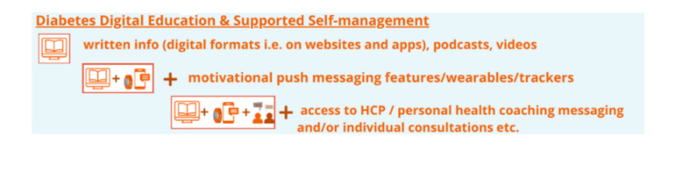
Type 1 Digital Diabetes Education Resources

Resource | Summary | Link
Learning Zone Diabetes Scotland | Variety of online resources and inter active tools.  10 languages | Learning Zone - Discover more about your diabetes. | Learning Zone
MyDiabetesMyWay | Online platform provides educational resources and access to health records. | Homepage | Information Site (scot.nhs.uk)
Remote DAFNE  (Dose Adjustment for Normal Eating) | Online program offering structured education managing Type 1, intensive insulin management with peer and educator support.  NICE | www.dafne.nhs.uk
DigiBete | Video platform and app.  Wide range of content, video clips, e-learning modules. BSL and 8 languages | www.digibete.org
BERTIE online  (Beta-cell Education Resources for Training in Insulin and Eating) | Range of interactive online modules regarding Type 1. | www.bertieonline.org.uk
X-PERT health  X-PERT Diabetes Digital Programme App. | Structures education programme delivered online or through HCP. 15 languages | X-PERT Health Diabetes Education and Weight Loss Programmes (xperthealth.org.uk)
MyFitnessPal | Support for tracking food intake | MyFitnessPal | MyFitnessPal
Carbs and Cals App | Support for carb and calorie counting | Carbs & Cals | Diabetes, Dieting & Calorie Counting App (carbsandcals.com)
ABCD Network (Association of British Clinical Diabetologists) | Educational resources around diabetes technology | Educational Resources for people living with diabetes | ABCD (Diabetes Care) Ltd
JDRF (Juvenile Diabetes Research Foundation) | Information and resources around living with Type 1 | Type 1 Diabetes Information and Support - JDRF, type 1 diabetes charity
NHS Inform | Basic information and signposting | Type 1 diabetes | NHS inform

Type 1 Written Resources

Resource | Outline | Link
Diabetes Scotland  Learning Zone | Information pack, Leaflets and resources. Range of languages | booklets & leaflets - Diabetes UK Shop
MyDiabetesMyWay | Information available on website (can be printed). Range of languages | Know More | Information Site (scot.nhs.uk)
DigiBete via Website | Website and printable resources on a range of topics .  BSL and 8 languages | Resources - DigiBete
Carbs and Cals | Books on carb and calorie counting | Carbs & Cals Books | Carb & Calorie Counter Book (carbsandcals.com)
BDA (British Dietetic Association) Factsheets | Food factsheets | Diabetes - Type 1 | British Dietetic Association (BDA)
NDR UK (Nutrition and Diet Resources UK) | Dietary advice leaflets | Diabetes | Nutrition and Diet Resources (ndr-uk.org)
TREND™(Training, research and education for nurses in diabetes) | Range of leaflets on managing diabetes | People with diabetes – Trend Diabetes
JDRF (Juvenile Diabetes Research Foundation) | Information and resources around living with Type 1; books and leaflets | Type 1 Diabetes Information and Support - JDRF, type 1 diabetes charity
NHS Inform | Basic information and signposting | Scottish health information you can trust | NHS inform
NHS Board Resources | Many Boards have locally made leaflets available to patients

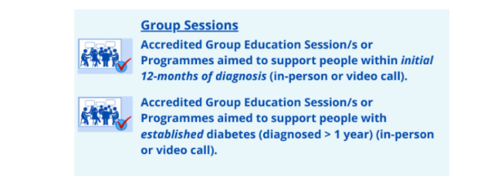

Type 1 Group Education Resources

Resource | Summary | Link
DAFNE (Dose Adjustment for Normal Eating) | Remote and in-person group education package. | Home - DAFNE
STEP (Scottish Type 1 Education Programme) | Structured education pathway, lesson plan and resources for New T1 DM. | Supply lesson plan via MS Teams
ADAPT (NHS Lanarkshire) | Local NHS Board developed group education programme

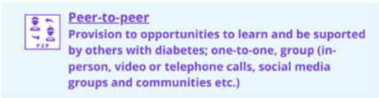

Peer Support

Resource | Summary | Link
Diabetes Scotland/UK | Local peer support groups, social media groups and online forum | Peer support groups | Diabetes UK
JDRF | Online forum, social media groups and regional events | The type 1 diabetes community - JDRF, the type 1 diabetes charity
Diabetes Together | Conference for people living with T1 and their families/carers | T-1 Today UK (t1todayuk.org)

Annexe B

EQIA Key Findings

Race: Culturally sensitive with resources available in different languages.
Delivery of education in different languages by skilled HCPs
Religion and belief: Cultural competence e.g. considering different diets, health habits/views, lifestyles etc.
Disability: Easyread documents/education adapted for LD needs e.g. Digibete. Working with LD teams to produce tools appropriate for the person with diabetes and their carers.
Accessibility of buildings, appointment times etc.
Impact of comorbidities on ability to undertake education.
Age: Consider potential lack of digital literacy.
Gender: Adapt marketing and ensure inclusive communication for all.
Pregnancy: Raise awareness within the primary/community healthcare teams and non-specialist staff. e.g. midwives (Type 1DM, Type 2 DM & GDM), pharmacists.
Sexual orientation/gender reassignment: General awareness raising as less likely to engage with services, need to ensure inclusive communication.
Deprivation: Need to target engagement in areas of deprivation and consider specific locality issues for socioeconomic inequalities. Review and adapt our current pathways which are person orientated vs healthcare systems.
Consider specific groups eg.homelessness services, prisons etc. Access to diabetes technology.
Islands Assessment: Impact of rural geography both on islands and the mainland; need to consider remote/digital and regional offerings. Sharing resources and staffing across boundaries. Ensure equal access to education and thus appropriate diabetes technology is not hampered by geography.

